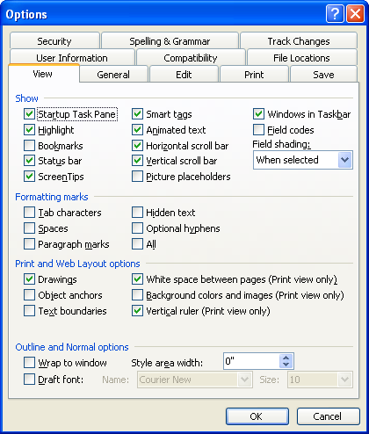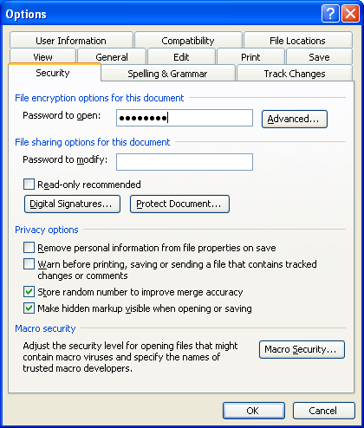
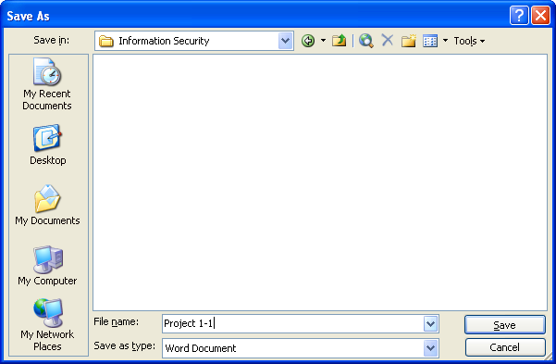 -> 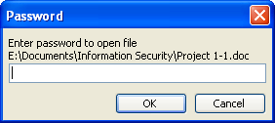
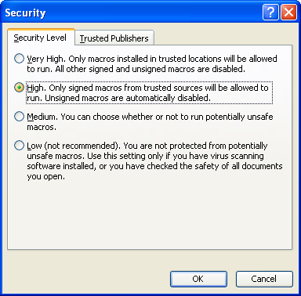
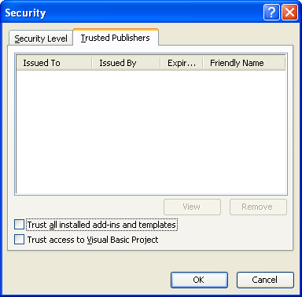
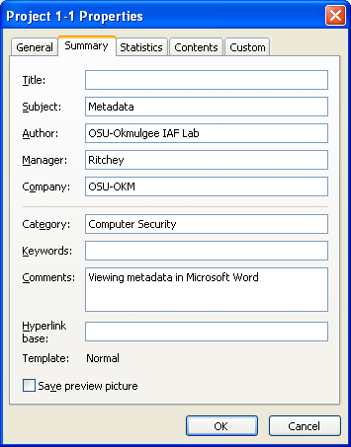
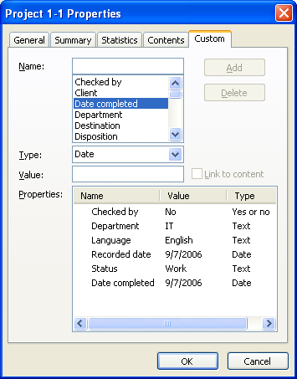

Summary
I’m good with Word, but this project actually taught me about a feature I had never used (Tools > Options > Security > Open Password). I always knew it was possible, but I wasn’t quite sure how. I also noticed they’ve spruced up the Macro Security dialog a lot since Office 97 (the last version of Office I ever bought). I’ve known about Metadata, but it never quite occurred to me that I could enter my own custom metadata fields. I also learned that Microsoft uses the term “Yes and No” instead of “Boolean”, which makes more sense to normal people I guess. I suppose one might say that this surprised me even. While typing this, it surprised me that I couldn’t align two images and a block of text on their centers and have it work right (the point line thing up there). In CSS, it’s a simple vertical-align: middle; -- but there is no such setting here (at least, not in the five minutes I messed with it to try to make it align center; it’ll do it, but move the images into the wrong spot and stuff). One thing that confused me is that the header is screwed up. Normally, the left tab is left aligned, the middle tab is center aligned, and the right tab is right aligned. For some reason, this is not true in this document. I blame my attempts at making the images align middle. Also, one thing that surprised me is that I can’t remember my instructor’s first name ☺.

